

Green University of Bangladesh

Department of Computer Science and Engineering (CSE)

Faculty of Sciences and Engineering

Semester: (Spring, Year:2022), B.Sc. in CSE (Day)

Course Title: Structured Programming Lab

Course Code: CSE 104 Section: Do

Lab Project Name : **Digital clock**

Student Details

|  |  |
| --- | --- |
| Name | ID |
| Nadim Mahmud Shehab | 221902021 |

Submission Date : 14/05/2022

Course Teacher’s Name: Md Solaiman Miya

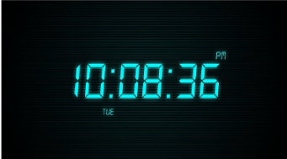

Table of Contents

**Chapter 1 Introduction**

1.1 Introduction 3

1.2 Design Goals/Objective 3

**Chapter 2 Design/Development/Implementation of the Project**

2.1 Methodology 4

2.2 Timer system 4

2.2.1 seven segment LED display system 4

**Chapter 3 Performance Evaluation**

3.1 Simulation Environment/ Simulation Procedure 5

3.2 Utilizing struct attributes 5

3.3 Displaying the digital clock 6

3.4 How to increment the time 6

3.5 Results and Discussions 7

3.6 A complete demo of our project 7

3.7 The output will be 8

**Chapter 4 Conclusion**

4.1 Introduction 8

4.2 Achivement 8

4.2.1 Technical 8

4.2.2 Non - technical 8

4.3 Limitation

4.3.1 Wiring Proficiency 9

4.3.2 Time Management 9

**References 9**

**Chapter 01**

**INTRODUCTION**

A Digital clock displays the current time.

It displays the time digitally(in numerals) in 12 hour format as

HH:MM:S

It displays the time digitally(in numerals) in 12 hour format as

HH:MM:S

It displays the time digitally(in numerals) in 12 hour format as

HH:MM:SS

It displays the time digitally(in numerals) in 12 hour format as

HH:MM:SS

It displays the time digitally(in numerals) in 12 hour format as

HH:MM:SS

It displays the time digitally(in numerals) in 12 hour format as

HH:MM:SS

It displays the time digitally(in numerals) in 12 hour format as

HH:MM:SS

It displays the time digitally(in numerals) in 12 hour format as

HH:MM:SS

It displays the time digitally(in numerals) in 12 hour format as

HH:MM:SS

It displays the time digitally(in numerals) in 12 hour format as

HH:MM:SS

It displays the time digitally(in numerals) in 12 hour format as

HH:MM:SS

It displays the time digitally(in numerals) in 12 hour format as

HH:MM:SS

It displays the time digitally(in numerals) in 12 hour format as

HH:MM:SS

It displays the time digitally(in numerals) in 12 hour format as

HH:MM:SS

It displays the time digitally(in numerals) in 12 hour format as

HH:MM:SS

The clock is built using sequential logic

Counters, decoders and seven segment displays are used

* 1. **Objective /Desing Goals**

While in this particular group, it was decided that the clock should have advanced functionalities as well apart from the required basic functions as follow: • Added counter: Accuracy degree is set to 0.1 by adding one more

(when reaching 29/59 seconds) • LED Display: A LED brights each time when the 1 second unit bit changes digit

* 1. **Background**

Time, something that exists in everyone’s life, is recorded by clocks all the time in our daily life. The present widely used counting system for time is decimal base as a result of the fact that this counting base is the most convenient one for people to count using ten fingers [1]. To be more precise about the counting system of time, it is commonly known that one day is divided into 24 hours, one hour is divided into 60 minutes and one minute is divided into 60 seconds, while this particular project particularly focused on building a digital clock that can count time for one minute.

* 1. **Requirement and Apparatus**

This project required the experimenters to design and simulate a circuit for a digital clock that counts from 1 to 59 seconds with switches to control the circuit by pausing, resetting or turning on/off it. The clock should be built on a breadboard using electronic components including IC chips - 74160, 7447, 7404, 7408 etc, 7-segment LED, switches, and sensors such as buzzer.

**Chapter 02**

**Design/Development/Implementation of the**

**Project**

**2.1 Methodology**

To develop DIGITAL CLOCK using 7 segment display. It shows hours, minute and second. Make it by using discrete components: a. Using IC 7408, 7400, 7447 & 74107. b. Designed Block Diagram, Logic Diagram and Circuit Diagram c. Component Description and Working

**2.2 Timer system**

The concrete circuit of the timer module is presented below in Figure 2.2. This circuit is in astable mode which produces “never stable” output in the form of a rectangular waveform clock signal. It primarily consists of a 555 timer IC chip, two resistors, and two capacitors.

**2.3- seven segment LED display system**

We use three flip flop which give 0 to 7 count output and remaining after other 4 flip flop give 0 to 15. But we know digital clock always displays 5 & 9 in minute but instead of it we required 0 to 5 count output in single seven segment displays so we connect the NAND gate which give low logic to flip flop and not allow it to exceeding from 5 digit number which is our requirement on single seven segment display. On the other hand the remaining four flip flop which want to give 0 to 15 but our requirement that it should display 0 to 9 count not to exceeding from it so we also here need NAND gate to stop it give us our prerequisite which is 0 to 9 count. When the circuits will displays successfully 5 & 9 in each seven segments display with the help of driver IC 7447 then it gives pulse to hour section. D. Hour section Designing the circuit in such a way so that the output resets to 0 0 0 automatically displaying 11.59.59. The counting proceeds with a frequency of one pulse peer hour coming from minute section. We used three J-K flip flop IC (74107) and in a single J-K flip flop IC it contain two flip flop. We know that hour would show 2 & 4 in each seven segment displays not greater than that number. So we need 0 to 2 displays count on first segment and 0 to 4 counts on other segment.

**Chapter 3**

**Performance Evaluation**

**3.1 Simulation Procedure**

I am use the following procedure to obtain the current time:

* Use the time library’s time() method in C++. It provides an object of type time with the current time as a value.
* Use the localtime() method to convert a time to a tm identifier. An identifier is a name used to refer to a class of objects.
* Declare a timePtr type pointer to hold the value returned by the localtime() function.
* The tm type allows us to manipulate time using characteristics such as tm sec, tm min, tm hour, and so on.
* Utilizing struct attributes

### 3.2Utilizing struct attributes

The arrow operator may be used to retrieve the properties of timeptr Set the time sec property to the value of the sec variable that you declared. Initialize the variable min with the tm min attribute before declaring another one with the same name. Use the tm hour property to set the hours variable to zero. Then, declare an AM/PM timestr variable. The code below stores the local time in variables using pointers. The if condition is used to change the local time to the 12-hour clock format

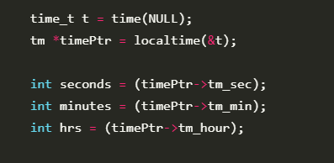

### 3.2 Displaying the digital clock:

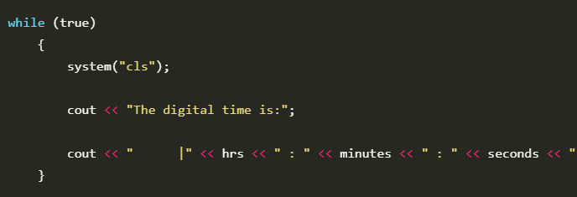

Since we have created our digital clock, the next step changes the time on **our digital clock.**

### 3.3 How to increment the time

Follow the procedure below to increment the time in our digital clock:

* Increment the sec variable on every iteration of the while loop.
* Once the sec value reaches 60, increment the min variable by one. Reset the sec back to one.
* In the same way, when the min reaches 60, increment hours by one and reset the min variable to 0.
* Set the hours to 00 when it reaches 24. This is because the standard time in the 24-hour system ranges from one to twenty-four.

After incrementing, the last step is to add a delay and clear the screen simultaneously.

To achieve this functionality, we will use the following steps:

* Use system(cls) to clear the view.
* We will add a 1000 ms delay using the sleep() function.

### 3.4 Result and Discusion

### Result and Discussion Our project has divided into four modules. They are as follows: A. 155 IC Timer Section The 555 timer IC is an integrated chip (IC) used in a variety of timer, pulse generator and oscillator application. . Second section We used total four JK FLIP FLOP (74107) and one single IC contains two flip flops. We use three flip flop which give 0 to 7 outputs and remaining other 4 flip flop give 0 to 15. . Instead of it we required 0 to 5 outputs in single seven segment display so we connect the NAND gate which gives low logic to flip flop and not allow it to exceeding from 5 digit number which is our requirement on single seven segment display. On the other hand, the remaining four flip flop which give 0 to 15 but our requirement that it should only display 0 to 9

### 3.5 A complete demo of our project

Here is the complete code for the digital clock application:

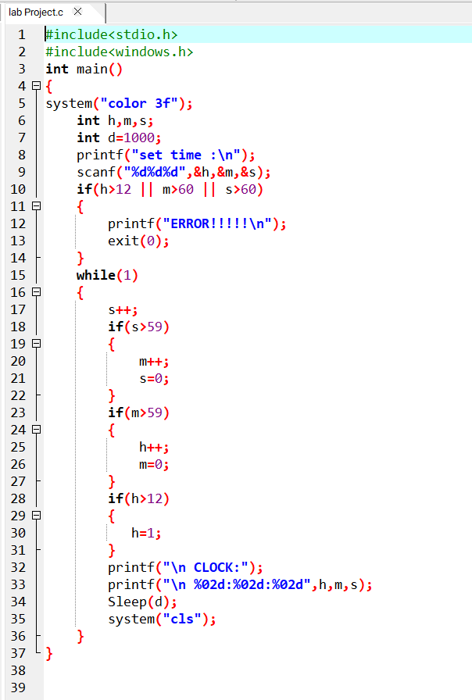

### 3.6The output will be :

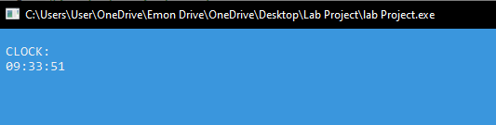

**Chapter 4**

**Conclusion**

**4.1 Introduction**

In the above tutorial, we have learned the steps required to create a digital clock. We also gained some knowledge on using if statements and while loops.

**4.2 Achievement**

**4.2.1 Technical**

The common used IC chips such as 74160,7447,AND/NAND/NOT gates were utilized effectively in this experiment. The working principle os these chips were also comprehensively learnt. The circuiting and wiring ability was practiced fully after finish the manual construction of this stopwatch circuit. The simulation software like multisim and PSpice were leant and effectively used in this lab to help the design of circuit as well.

**4.2.2 Non-technical**

The time management skill was practiced in the long-term project. We basically spent all of our Tuesdays and Wednesdays on the circuit construction section of the project. Also, the teamwork ability was practiced as well: we worked as a group in the whole process of this project by dividing the workload and discussing solution and creative ideas about the circuit design and construction.

**4.3 Limitation**

**4.3.1 Wiring Proficiency**

The circuit seems not to have the perfectly clear wiring pattern as can be seen in Appendix A. This is because we did not really pay enough attention on the out-looking of the circuit but simply focused on the functions. Therefore, the wires tended to be not perfectly beautiful. We should have considered the looking at the beginning.

**4.3.2 Time Management**

We wanted to add the counting down the function to the circuit as well in the process of the design of the circuit. However, we had to buy extra chips online when the time left did not allow that purchase delay. We should have planned early about this function and bought the chips early.

**Reference**

[1] “Why is a minute divided into 60 seconds, an hour into 60 minutes, yet there are only 24 hours in a day?”. [Online]. Available: https://www.scientificamerican.com/article/experts-time-division-days-hours-minute